**CENTURION UNIVERSITY OF TECHNOLOGY AND MANAGEMENTS**



**Assignment 1**

Course Title: System Integration with Dymola

Course Code: CUTM1022 (0-0-2)

**Submitted to:**

*Dr. Sudhansu Kumar Samal*

*Faculty of*

*School of Engineering & Technology, Bhubaneswar*

**Submitted by:**

Name: Kiran Kumar Malik

Registration no: 200301120128

Branch: B-Tech in Computer Science and Engineering’s

Semester: 4th Sem

Section: C

**Experiment No.: 1**

To measure the current of DC (Direct Connection) and AC (Alternative Current) connections.

**Requirements:**

OpenModelica software

**Procedure:**

***DC Current Measurement***

Step 1: Open Openmodelica connection editor

Step 2: Click on New Modelica class, give a new Modelica class name, then click on ok

Step 3: Then this type of page will appear

Step 4: Go to Modelica packages, then go to electrical, then analog, then basic, then drag resistor and ground to the modeling field , then choose the constant voltage from source packages.

After that I connected the connection between the positive end of the resistor and constanttvoltage, then connected the connection between the negative end of the resistor and constantvoltage.after that connected the connection between ground and negative connection of constantvoltage.

Add some information of the modeling

Step 5: After the completion of modeling then save the Modelica file into your pc as .mo extensions, after that go for simulation, when clicking on simulation then compilation occurs, graphical language changes into modelica language.

model Assignment_1DC

Modelica.Electrical.Analog.Basic.Resistor resistor(R = 10) annotation(

Placement(visible = true, transformation(origin = {0, 62}, extent = {{-18, -18}, {18, 18}}, rotation = 0)));

Modelica.Electrical.Analog.Basic.Ground ground annotation(

Placement(visible = true, transformation(origin = {1, -77}, extent = {{-17, -17}, {17, 17}}, rotation = 0)));

Modelica.Electrical.Analog.Sources.ConstantVoltage constantVoltage(V = 100) annotation(

Placement(visible = true, transformation(origin = {-64, 0}, extent = {{-16, -16}, {16, 16}}, rotation = -90)));

equation

connect(constantVoltage.n, ground.p) annotation(

Line(points = {{-64, -16}, {-64, -60}, {2, -60}}, color = {0, 0, 255}));

connect(constantVoltage.n, resistor.n) annotation(

Line(points = {{-64, -16}, {-64, -40}, {40, -40}, {40, 62}, {18, 62}}, color = {0, 0, 255}));

connect(constantVoltage.p, resistor.p) annotation(

Line(points = {{-64, 16}, {-64, 62}, {-18, 62}}, color = {0, 0, 255}));

annotation(

uses(Modelica(version = "4.0.0")),

Documentation(info = "<html><head></head><body><!--StartFragment--><span style=\"font-family: 'MS Shell Dlg 2'; font-size: 12px;\">In this DC (Direct Current) connection, we have taken</span><div style=\"font-family: 'MS Shell Dlg 2'; font-size: 12px;\"><br></div><div style=\"font-family: 'MS Shell Dlg 2'; font-size: 12px;\">V=100V</div><div style=\"font-family: 'MS Shell Dlg 2'; font-size: 12px;\">R=10ohm</div><div style=\"font-family: 'MS Shell Dlg 2'; font-size: 12px;\">I=10A</div><div style=\"font-family: 'MS Shell Dlg 2'; font-size: 12px;\"><br></div><div style=\"font-family: 'MS Shell Dlg 2'; font-size: 12px;\">In my setup, I took the following models</div><div style=\"font-family: 'MS Shell Dlg 2'; font-size: 12px;\">1. Resistor</div><div style=\"font-family: 'MS Shell Dlg 2'; font-size: 12px;\">2. sine voltage</div><div style=\"font-family: 'MS Shell Dlg 2'; font-size: 12px;\">3. Ground</div><div style=\"font-family: 'MS Shell Dlg 2'; font-size: 12px;\">I connected the connection between the positive end of the resistor and constantvoltage, then connected the connection between the negative end of the resistor and constantvoltage.after that connected the connection between ground and negative connection of constantvoltage.</div><div style=\"font-family: 'MS Shell Dlg 2'; font-size: 12px;\">After the finishing of modelling then save it into your system and go for simulation.</div><!--EndFragment--></body></html>"));

end Assignment_1DC;

Step 6:after the compilation it will show you a plotting area where you have to plot, as per your given data you have to simulate.

***AC Current Measurement***

Step 1: Open Openmodelica connection editor

Step 2: Click on New Modelica class, give a new Modelica class name, then click on ok

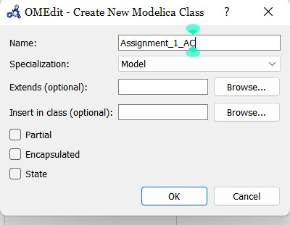

Step 3: Then this type of page will appear

Step 4: Go to Modelica packages, then go to electrical, then analog, then basic, then drag resistor and ground to the modeling field , then choose the constant voltage from source packages.

After that I connected the connection between the positive end of the resistor and sinevoltage, then connected the connection between the negative end of the resistor and sinevoltage.after that connected the connection between ground and negative connection of sinevoltage.

Add some information of the modeling

Step 5: After the completion of modeling then save the Modelica file into your pc as .mo extensions, after that go for simulation, when clicking on simulation then compilation occurs, graphical language changes into modelica language.

model Assignment_1_AC

Modelica.Electrical.Analog.Basic.Resistor resistor(R = 10) annotation(

Placement(visible = true, transformation(origin = {-1, 65}, extent = {{-17, -17}, {17, 17}}, rotation = 0)));

Modelica.Electrical.Analog.Sources.SineVoltage sineVoltage(V = 100, f = 50) annotation(

Placement(visible = true, transformation(origin = {-65, -1}, extent = {{-19, -19}, {19, 19}}, rotation = -90)));

Modelica.Electrical.Analog.Basic.Ground ground annotation(

Placement(visible = true, transformation(origin = {-11, -67}, extent = {{-15, -15}, {15, 15}}, rotation = 0)));

equation

connect(sineVoltage.p, resistor.p) annotation(

Line(points = {{-64, 18}, {-66, 18}, {-66, 66}, {-18, 66}}, color = {0, 0, 255}));

connect(sineVoltage.n, resistor.n) annotation(

Line(points = {{-64, -20}, {-64, -28}, {36, -28}, {36, 66}, {16, 66}}, color = {0, 0, 255}));

connect(sineVoltage.n, ground.p) annotation(

Line(points = {{-64, -20}, {-64, -52}, {-10, -52}}, color = {0, 0, 255}));

annotation(

uses(Modelica(version = "4.0.0")),

Documentation(info = "<html><head></head><body><!--StartFragment--><span style=\"font-family: 'MS Shell Dlg 2'; font-size: 12px;\">In this AC (Alternative Current) connection, we have taken</span><div style=\"font-family: 'MS Shell Dlg 2'; font-size: 12px;\"><br></div><div style=\"font-family: 'MS Shell Dlg 2'; font-size: 12px;\">V=100V</div><div style=\"font-family: 'MS Shell Dlg 2'; font-size: 12px;\">R=10ohm</div><div style=\"font-family: 'MS Shell Dlg 2'; font-size: 12px;\">I=10A</div><div style=\"font-family: 'MS Shell Dlg 2'; font-size: 12px;\">f=50Hz</div><div style=\"font-family: 'MS Shell Dlg 2'; font-size: 12px;\"><br></div><div style=\"font-family: 'MS Shell Dlg 2'; font-size: 12px;\">In my setup, I took the following models</div><div style=\"font-family: 'MS Shell Dlg 2'; font-size: 12px;\">1. Resistor</div><div style=\"font-family: 'MS Shell Dlg 2'; font-size: 12px;\">2. sine voltage</div><div style=\"font-family: 'MS Shell Dlg 2'; font-size: 12px;\">3. Ground</div><div style=\"font-family: 'MS Shell Dlg 2'; font-size: 12px;\">I connected the connection between the positive end of the resistor and sinetvoltage, then connected the connection between the negative end of the resistor and sinevoltage.after that connected the connection between ground and negative connection of sinevoltage.</div><div style=\"font-family: 'MS Shell Dlg 2'; font-size: 12px;\">After the finishing of modelling then save it into your system and go for simulation.</div><!--EndFragment--></body></html>"));

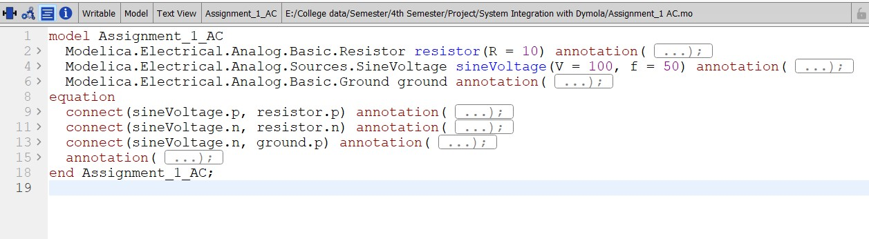end Assignment_1_AC;

Step 6: After the compilation it will show you a plotting area where you have to plot, as per your given data you have to simulate.



